(Store/library/school name) is Proud to be a 106th Anniversary Children’s Book Week Event Host

Celebrate with us May November 3rd - 9th!

FOR IMMEDIATE RELEASE
City, State — date —As part of the longest-running national celebration of books for young people and the joy of reading, over 2,300 schools, libraries, and bookstores from coast to coast in all 50 states will celebrate Children’s Book Week, November 3 - 9.

This year marks the 106th anniversary of Children’s Book Week; the theme for this year’s celebration is An Ocean of Stories. The 2025 Children’s Book Week poster was created by Julie Flett. Julie invites readers, young and old, to join the fun as the year’s poster artist.

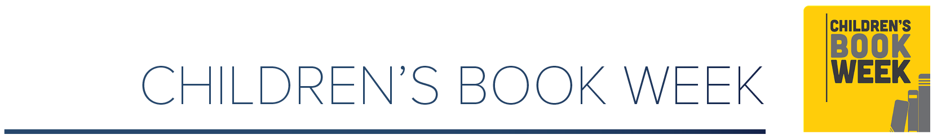
We are proud to be hosting the following event(s) in celebration of Children’s Book Week:
INSERT EVENT DETAILS
Date
Location
Time
Description

Everyone can access original bookmarks created by five acclaimed illustrators, activity pages by Julie and other beloved book creators, and information about this year’s reading club, #StoryOcean.

Children’s Book Week is a cornerstone program of Every Child a Reader, a 501(c)(3) literacy charity dedicated to inspiring a lifelong love of reading in children and teens across America. Other national programs include Get Caught Reading and the National Ambassador for Young People’s Literature—in partnership with the Library of Congress.

Contact:
Your name and title; contact information

